

R. Erwin, Export-U Program Director
4/27/18

Executive Summary:
For several years, the International Trade Center of the University of Georgia SBDC has used various forms of market assessment to help its clients prioritize and select their overseas markets. Over time, this methodology has gradually been refined into a somewhat standardized set decision-making tools. (Ref.: Webinars 2a & 2b, www.Export-U2.com)

We generally refer to the most sophisticated of these tools as MATRIX Analysis, simply because it relies on a massive PowerPoint spreadsheet. Our formal name for the thing is “Multi-Attribute Analysis of Export Markets,” or MMA for short, but honestly that's a mouthful and nobody really calls it that.
It is roughly....and I mean very roughly, based on NASA's “Probabilistic Risk Assessment” or PRA methodology, which was used in the early days of the space program to estimate the risks inherent to space-flight. Because of its partially subjective nature, the MATRIX is not a statistically valid process, but it can be a powerful aid for strategic decision-making. It gives companies numeric opportunity rankings of 186 countries.

Background:
The MATRIX was created for one purpose only: to help US companies rate the relative export potential of foreign markets. To do so, it simultaneously considers a wide range of seemingly incompatible data, which it scales and sums to derive country opportunity scores.
NASA employed sophisticated software to assess the risks associated with space travel; we simply use a rather large Excel spreadsheet.
Over the years, the MATRIX has proven especially helpful to larger clients trying to rate their export potential in numerous countries. Its primary value is to:
- Identify the best export markets for the company’s product(s), while taking into account its capabilities and preferences.
- Eliminate “bad,” “risky,” or unpromising markets,
- Narrow the company’s focus on just a few prime geographic targets ,

The Process

By its nature, international market research is a non-linear and organic process, and the type of input data varies tremendously with each company and product.
We have found that one can make the process much less intimidating to the client by applying a little artificial structure and sequence, roughly as follows:
- Find product’s HS code
- Mine for data
(trade, demographics, special product factors, risk, etc.)
- Sort data into categories
(Here we use just 3: macroeconomic, commercial/trade, and risk)
- Analyze data to rate markets


A. Data Acquisition: Prior to mining international trade data, you must determine which HS code(s) apply to the product(s) under study. This can be accomplished simply by googling “What is the HS code for [product].” A more precise answer may be found using the “Schedule B Search Engine” (https://uscensus.prod.3ceonline.com/), which operates from a keyword search.
With the HS code(s) in hand, you can then begin locating and extracting the relevant data on international trade volume and trends. These can give you a good initial picture of where the product is imported and where the US is most competitive.
One common misconception is that there is not enough input data from which to make global market decisions. In fact, the opposite is true, and researchers are often subject to data overload. There is just so much complex, overlapping, and sometimes contradictory information out there that it can become a massive blur.
Locating relevant trade data is a major subject unto itself, and outside the scope of this paper. Suffice it to say, there are tons of data out there, some more relevant than others. Much of it available for free over the internet. (Over one-hundred of our favorite sources may be found at http://www.export-u.com/html/links.html.)

B. Basic Data Analysis
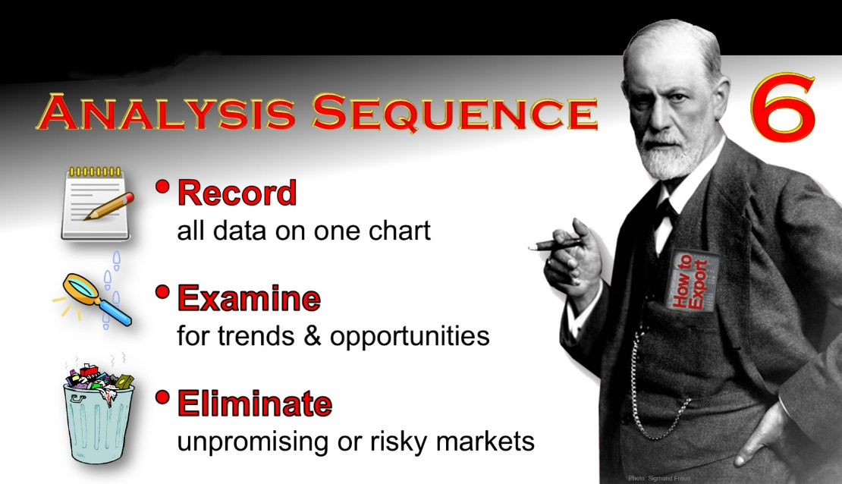
In many cases, clients are well served by less demanding analysis than our full MATRIX. For example, a simple Recording Chart can display the relevant data so it can then be visually examined for the confluence of negative and positive market factors. This works best for a quick assessment of a limited number of markets, e.g., for the Caribbean Region.
Figure 1: Recording Chart analysis sequence.
A modest refinement of the recording chart uses a color dots to indicate positive and negative information, much like Consumer Reports uses for household appliances. (We sometimes refer to it as a Mini-MATRIX.)
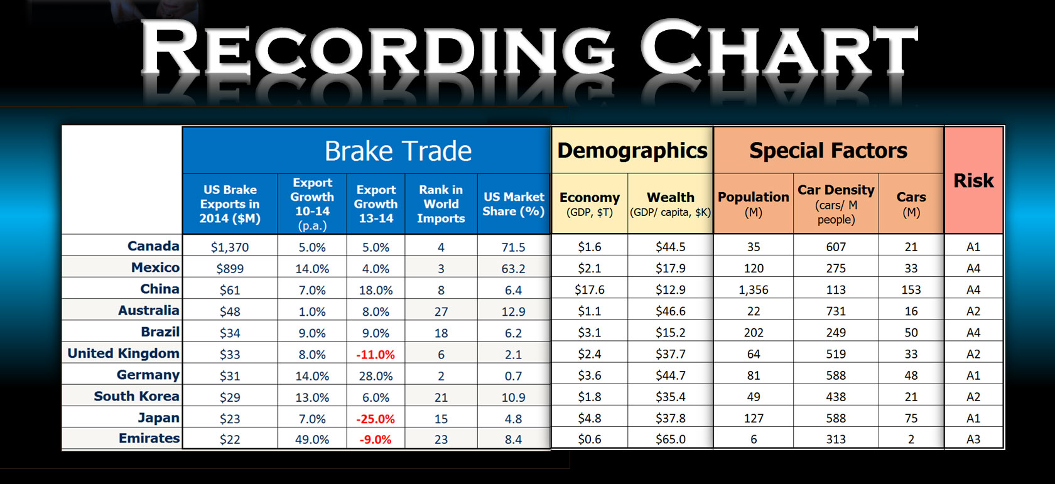
Figure 2: Simple Recording Chart example for an exporter of automotive brake parts. Note how the negative growth figures in red stand out.
C. MATRIX Analysis
(To better follow the narrative in this section, we recommend that you download the sample MATRIX analysis from our website at http://www.export-u2.com/RESOURCES/Other-Downloads/other-downloads.html.)
When you are working with larger clients that must consider numerous world markets, a full MATRIX market analysis is warranted. However, be aware that it requires considerable labor, and may take several days of work to complete.

Data Inputs:
To begin the analysis, we must insert all of our data into the MATRIX on the appropriate input page of the spreadsheet. These input pages then populate the MASTER CHART, per below.
- Indicators (top row): All input data in our MATRIX analysis is grouped under three broad categories we call “Indicators.” Over the years, we have gradually settled on: Macroeconomic Data, Commercial and Trade Data, and Risk Data. But, you can subdivide Indicators or add new Indicator categories as appropriate.
- Attributes (2nd row): The actual input datasets are called “Attributes.” All Attribute datasets are entered on their own tabbed spreadsheet pages which then populate the MASTER CHART.

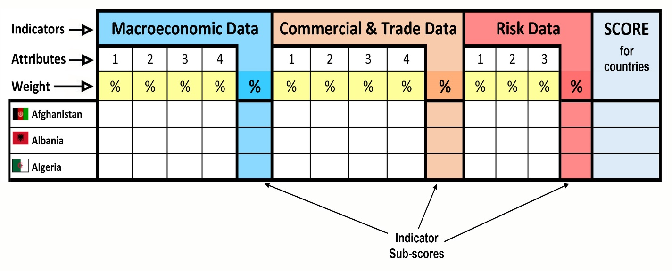
- Weight % (3rd row): Here we assign the weight, or relative importance of each Attribute and Indicator. The Weights within each Indicator group must always total 100%. Similarly, the weights given to the three Indicator groups must also total 100%. As an example, if we set Macroeconomic weight at 20% and Commercial & Trade at 50%, then by default Risk must be 30%. (20% + 50% +30% = 100%)
Figure 3: Simplified diagram of the Matrix Master Chart layout.
Now, here’s where it gets interesting: If we decide that an attribute like “competitor density” is bad, then we can give it a negative weight (say, -20%). However, the group total must still equal 100%. To accomplish this must boost the other assigned weights in the group. (e.g.: -20% + 80% + 40% = 100%) I know it sounds strange, but in practice it’s quite easy and effective. Clients can adjust the weight assigned to each Attribute and Indicator, to modify the outcome, and better reflect their priorities. This part of the process is clearly subjective.
In our office, we update the Macroeconomic and Risk Indicator data once each year, since it does not change from one analysis to the next. Only Commercial & Trade Data must be customized for each client and product. This greatly reduces the labor per analysis.

Here is an example of the Indicators and Attributes we used for a medical software exporter:

- Macroeconomic data:
- Wealth
- Growth
- Projected Growth
- Population
- Economy Size
- Commercial and Trade data:
- Health Care Spending per Capita
- Total Health Care Spending
- IT Development Index
- Medical Tech Imports from the US
- Computer Imports
- Network Readiness Index
- Physicians per 1,000 People
- Public Health Care Spending %
- Risk data:
- Country Risk
- Business Climate (difficulty)
- Banking

Results:

The trick to merging all of this different data into a single analysis is to put everything on a common scale, so it can be combined and manipulated. In our office, we have settled on a scale of
+100 to -100, with zero representing the median value. We like this scale because Excel can display the negative numbers in red, making them easy to spot.

The formulas behind this alchemy are imbedded within the input pages. Typically, “soft” data (like A-B-C risk ratings) is first converted to numbers for the analysis.

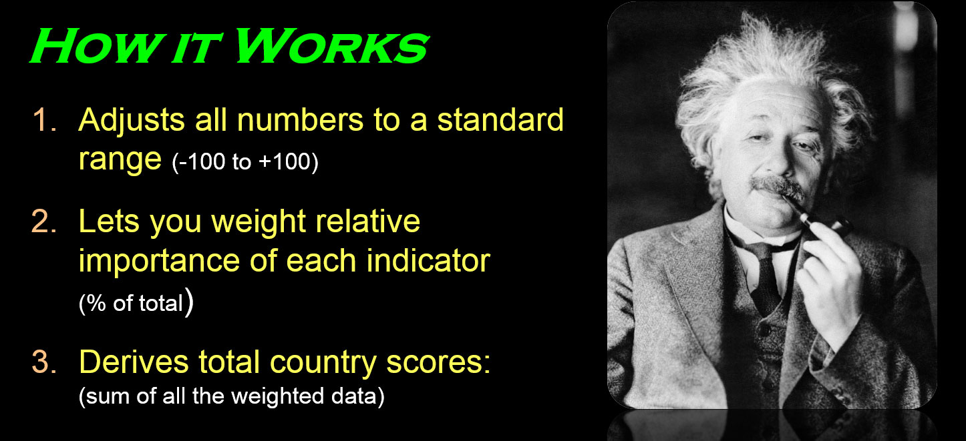
The countries are all listed alphabetically by row, and they occupy the same row on every page of the spreadsheet. Thus, Afghanistan is in row 8 on every page, making it much easier to link data and formulas between pages.
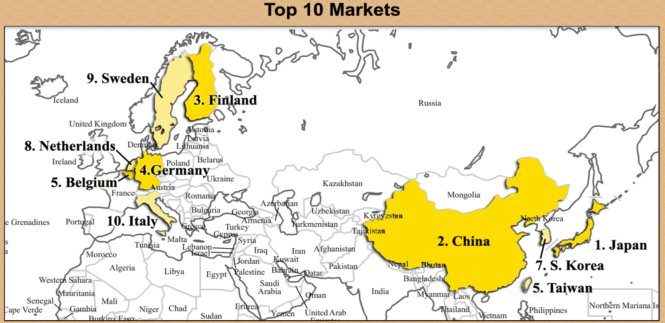
Our ultimate objective is to give each market a clear numeric score (+100 to -100), and then to create a map showing the top markets.
Clients may also interact with the MATRIX and adjust the weightings to see how they affect the outcome. Such interaction brings the client into the process, rather than simply presenting him or her with “the answer.” Thus, the MATRIX becomes a true decision-making tool.

D. Example: Fast Food Franchise

We will now consider how this procedure was used several years ago to help a client set global expansion priorities for their restaurant chain.
While this an older example, it illustrates how a client’s pro-active input can yield good actionable market intelligence. The data has been altered to protect client’s identity.
The client’s chain has operated for more than 35 years, and has several thousand units in the US and several hundred overseas in some 20 countries.
The offshore units are operating with varying degrees of success. Many came about as a result of rather serendipitous business contacts (e.g., they met someone at a trade show; they saw the client’s website), rather than through any conscious strategy. The chain’s food is hot and spicy, and because of religious preferences in many markets, they wish to lead with their poultry sandwiches rather than with the standard burgers. From their overseas experience, the client knows that the presence of other competing chains can be a positive Attribute, as long as the market is not too saturated.
The company wanted to develop a target “hit list” of the most promising global markets. According to its CEO, “There is nothing wrong with picking the low hanging fruit.”
Company established search criteria:

- Market healthy & growing
- Product affordable,
- Operating costs OK (rent, utilities, etc.),
- Consumers like poultry,
- Competition exists but not intense
- Risk acceptable

Selected Indicators & Attributes:
- Demographics: population size, % youth, % urban, % population growth, and Human Development Index (a UN rating of economic maturity)
- Macroeconomics: GDP, wealth, and GDP growth rate
- Microeconomics: competition, rent cost, poultry cost, labor cost, and utility cost
- Market preference: poultry consumption, and hot food consumption
- Risk: country risk rating.
This was a comprehensive global assessment that included over 180 countries. A small section of the Master Chart is shown below.
The yellow row lists the Weight % assigned to each of the Attributes above it. The Weight % within each Attribute group totals 100%. (The last attribute Weight % in each Indicator group automatically adjusts so the total will always be 100 %.)
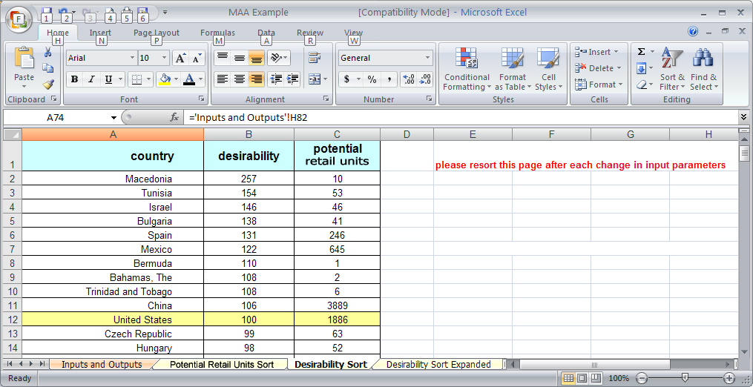
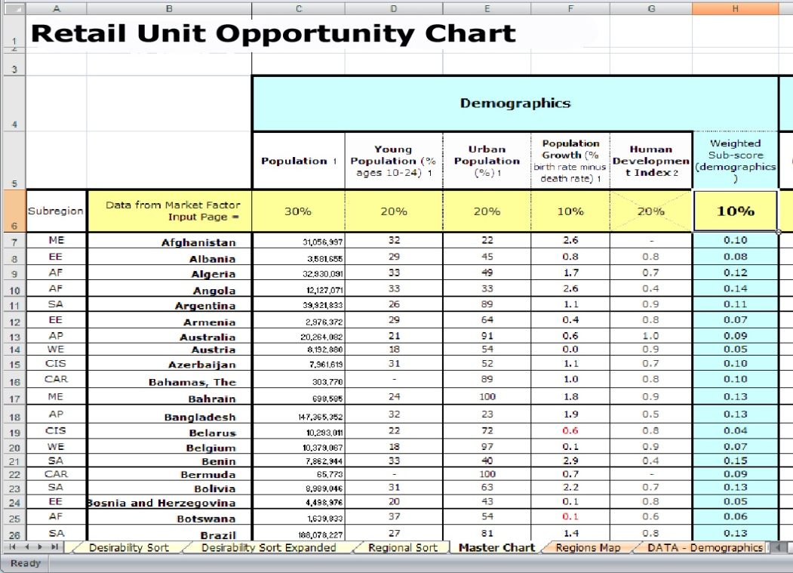
The tabs along the bottom are for the data input pages.
To make the information easier to digest, we copied the final Market Desirability scores to a separate summary sheet (Figure 6). It also shows the projected number of units that market could support. This is simply a reflection of the client’s given ideal retail unit density.
Figure 5: Excerpt from the "Master Spreadsheet" showing arrangement of Attributes within the Demographic Indicator group. Row 6 (yellow) shows the Weight assigned to each Attribute above in row 5.
This is important because some markets like Bermuda and the Bahamas have excellent desirability ratings but can only support a small number of units.
Figure 6: Top section of the results summary page showing final market desirability ratings. (In more recent analyses, the top rated country would have a +100 score, and the worst -100.)

V. Final Analysis
The ultimate point of the analysis is to do a quadrant graph intersecting both market potential and desirability. Those markets that show up in both high potential and high desirability sorts are the prime targets. Essentially, these become your targets of maximum opportunity and minimum risk.
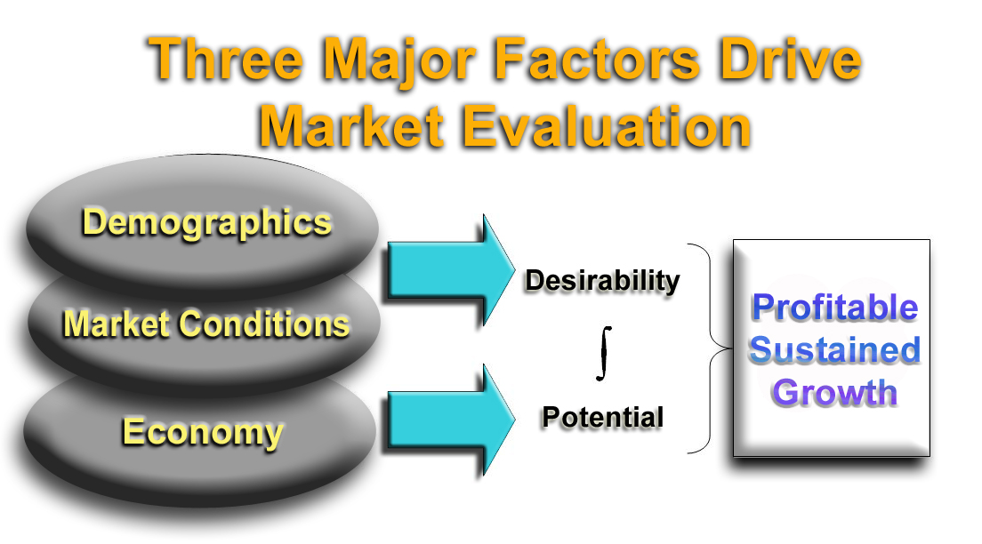

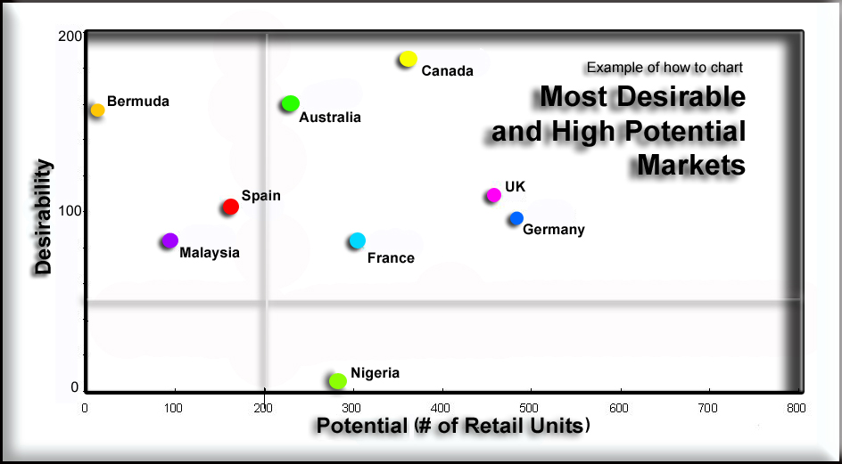
As we explained at the beginning of this presentation, this is not statistically valid method for deriving “the” answer. Rather it is a tool to help our trade clients evaluate overseas markets. This client has used this methodology for several years to guide their overseas sales efforts and has located several dozen retail units in the highly rated markets.

